1/31/2025

22F-3194 Talha Abdullah Bangyal

BS(AI) – 4A

Database System Lab

Lab 1

**Task 1**

#include<iostream>

#include<fstream>

#include<string>

using namespace std;

struct Student {

int id;

string name;

int age;

string course;

};

void insertdata();

void display();

void editdata(int id);

void removedata(int id);

int main() {

int choice, id;

while (true) {

cout << "\nStudent Record Management System" << endl;

cout << "1. Insert Student Record" << endl;

cout << "2. View All Student Records" << endl;

cout << "3. Delete Student Record by ID" << endl;

cout << "4. Update Student Record by ID" << endl;

cout << "5. Exit" << endl;

cout << "Enter your choice: ";

cin >> choice;

switch (choice) {

case 1:

insertdata();

break;

case 2:

display();

break;

case 3:

cout << "Enter Student ID to delete: ";

cin >> id;

removedata(id);

break;

case 4:

cout << "Enter Student ID to update: ";

cin >> id;

editdata(id);

break;

case 5:

cout << "Exiting the program..." << endl;

return 0;

default:

cout << "Invalid choice! Please try again." << endl;

}

}

system("pause");

return 0;

}

void insertdata() {

ofstream file("student.txt", ios::app);

if (!file) {

cout << "Error opening file!" << endl;

return;

}

Student s;

cout << "Enter the student id: ";

cin >> s.id;

cin.ignore();

cout << "Enter the student Name: ";

getline(cin, s.name);

cout << "Enter the student Age: ";

cin >> s.age;

cin.ignore();

cout << "Enter the student Course: ";

getline(cin, s.course);

file << s.id << "\n" << s.name << "\n" << s.age << "\n" << s.course << endl;

file.close();

cout << "Student record inserted successfully!" << endl;

}

void display() {

ifstream file("student.txt");

if (!file) {

cout << "Error opening file!" << endl;

return;

}

Student s;

cout << "Student Records" << endl;

while (file >> s.id) {

file.ignore();

getline(file, s.name);

file >> s.age;

file.ignore();

getline(file, s.course);

cout << "ID: " << s.id << ", Name: " << s.name << ", Age: " << s.age << ", Course: " << s.course << endl;

}

file.close();

}

void editdata(int id) {

ifstream file("student.txt");

ofstream tempFile("temp.txt");

if (!file || !tempFile) {

cout << "Error opening file!" << endl;

return;

}

Student s;

bool found = false;

while (file >> s.id) {

file.ignore();

getline(file, s.name);

file >> s.age;

file.ignore();

getline(file, s.course);

if (s.id == id) {

found = true;

cout << "Enter new Student Name: ";

cin.ignore();

getline(cin, s.name);

cout << "Enter new Student Age: ";

cin >> s.age;

cin.ignore();

cout << "Enter new Student Course: ";

getline(cin, s.course);

}

tempFile << s.id << "\n" << s.name << "\n" << s.age << "\n" << s.course << endl;

}

file.close();

tempFile.close();

remove("student.txt");

rename("temp.txt", "student.txt");

if (found) {

cout << "Student record updated successfully!" << endl;

}

else {

cout << "Student record not found!" << endl;

}

}

void removedata(int id) {

ifstream file("student.txt");

ofstream temp("temp.txt");

if (!file || !temp) {

cout << "Error opening file!" << endl;

return;

}

Student s;

bool found = false;

while (file >> s.id) {

file.ignore();

getline(file, s.name);

file >> s.age;

file.ignore();

getline(file, s.course);

if (s.id != id) {

temp << s.id << "\n" << s.name << "\n" << s.age << "\n" << s.course << endl;

}

else {

found = true;

}

}

file.close();

temp.close();

remove("student.txt");

rename("temp.txt", "student.txt");

if (found) {

cout << "Student record deleted successfully!" << endl;

}

else {

cout << "Student record not found!" << endl;

}

}

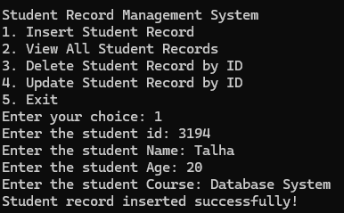

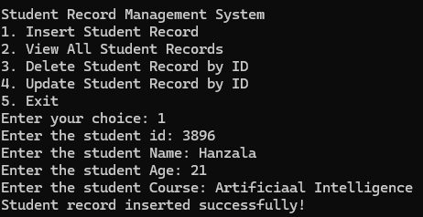

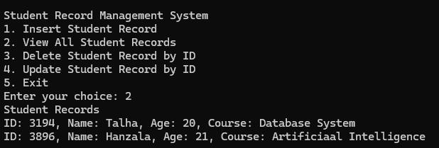

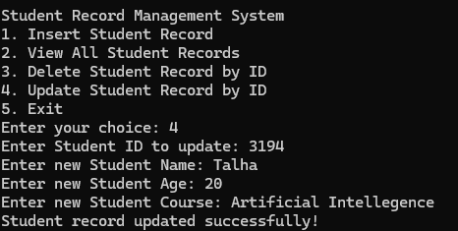

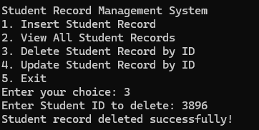

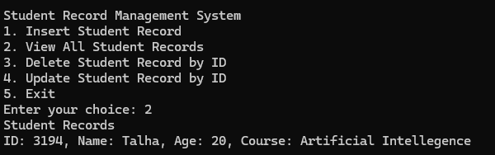

**Task 2**

#include<iostream>

#include<fstream>

#include<string>

using namespace std;

struct Product {

int id;

string name;

double price;

int quantity;

};

void insertproduct();

void display();

void editproduct(int id);

void removeproduct(int id);

int main() {

int choice, id;

while (true) {

cout << "\nProduct Record Management System" << endl;

cout << "1. Insert Product Record" << endl;

cout << "2. View All Product Records" << endl;

cout << "3. Delete Product Record by ID" << endl;

cout << "4. Update Product Record by ID" << endl;

cout << "5. Exit" << endl;

cout << "Enter your choice: ";

cin >> choice;

switch (choice) {

case 1:

insertproduct();

break;

case 2:

display();

break;

case 3:

cout << "Enter Product ID to delete: ";

cin >> id;

removeproduct(id);

break;

case 4:

cout << "Enter Product ID to update: ";

cin >> id;

editproduct(id);

break;

case 5:

cout << "Exiting the program..." << endl;

return 0;

default:

cout << "Invalid choice! Please try again." << endl;

}

}

system("pause");

return 0;

}

void insertproduct() {

ofstream file("product.txt", ios::app);

if (!file) {

cout << "Error opening file!" << endl;

return;

}

Product p;

cout << "Enter the Product id: ";

cin >> p.id;

cin.ignore();

cout << "Enter the Product Name: ";

getline(cin, p.name);

cout << "Enter the Product Price: ";

cin >> p.price;

cout << "Enter the Product Quantity: ";

cin >> p.quantity;

file << p.id << "\n" << p.name << "\n" << p.price << "\n" << p.quantity << endl;

file.close();

cout << "Product record inserted successfully!" << endl;

}

void display() {

ifstream file("product.txt");

if (!file) {

cout << "Error opening file!" << endl;

return;

}

Product p;

cout << "Product Records" << endl;

while (file >> p.id) {

file.ignore();

getline(file, p.name);

file >> p.price;

file >> p.quantity;

file.ignore();

cout << "ID: " << p.id << ", Name: " << p.name << ", Price: " << p.price << ", Quantity: " << p.quantity << endl;

}

file.close();

}

void editproduct(int id) {

ifstream file("product.txt");

ofstream temp("temp.txt");

if (!file || !temp) {

cout << "Error opening file!" << endl;

return;

}

Product p;

bool found = false;

while (file >> p.id) {

file.ignore();

getline(file, p.name);

file >> p.price;

file >> p.quantity;

file.ignore();

if (p.id == id) {

found = true;

cout << "Enter new Product Name: ";

cin.ignore();

getline(cin, p.name);

cout << "Enter new Product Price: ";

cin >> p.price;

cout << "Enter new Product Quantity: ";

cin >> p.quantity;

}

temp << p.id << "\n" << p.name << "\n" << p.price << "\n" << p.quantity << endl;

}

file.close();

temp.close();

remove("product.txt");

rename("temp.txt", "product.txt");

if (found) {

cout << "Product record updated successfully!" << endl;

}

else {

cout << "Product record not found!" << endl;

}

}

void removeproduct(int id) {

ifstream file("product.txt");

ofstream temp("temp.txt");

if (!file || !temp) {

cout << "Error opening file!" << endl;

return;

}

Product p;

bool found = false;

while (file >> p.id) {

file.ignore();

getline(file, p.name);

file >> p.price;

file >> p.quantity;

file.ignore();

if (p.id != id) {

temp << p.id << "\n" << p.name << "\n" << p.price << "\n" << p.quantity << endl;

}

else {

found = true;

}

}

file.close();

temp.close();

remove("product.txt");

rename("temp.txt", "product.txt");

if (found) {

cout << "Product record deleted successfully!" << endl;

}

else {

cout << "Product record not found!" << endl;

}

}

